INTERNATIONAL WORKSHOP - INTEGRATION OF GEOSPHERES IN EARTH SYSTEMS: MODERN QUERIES TO ENVIRONMENTAL PHYSICS, MODELLING, MONITORING & EDUCATION
Dubrovnik, Croatia, 30 April – 3 May 2011

Alexander A. Baklanov¹, Valeriy G. Bondur², Zvjezdana B. Klaić³, Sergej S. Zilitinkevich^{4,5}
¹Danish Meteorological Institute, Copenhagen, Denmark
²AEROCOSMOS Scientific Centre, Moscow, Russia
³ Andrija Mohorovičić Geophysical Institute, Department of Geophysics, Faculty of Science, University of Zagreb, Croatia
⁴Division of Atmospheric Sciences, University of Helsinki, Finland
⁵Finnish Meteorological Institute, Helsinki, Finland

The workshop “Integration of Geospheres in Earth Systems: Modern Queries to Environmental Physics, Modelling, Monitoring & Education” was a joint meeting of the four ongoing projects:
- PBL-PMES “Atmospheric Planetary Boundary Layers - Physics, Modelling and Role in Earth Systems” (FP7 Specific programme IDEAS, ERC Advanced Grant No. 227915, 2009-2013, coordinator S.S. Zilitinkevich) http://pbl-pmes.fmi.fi/;
- MEGAPOLI “Megacities: Emissions, urban, regional and Global Atmospheric POLlution and climate effects, and Integrated tools for assessment and mitigation (FP7-ENV-2007.1.1.2.1 project 212520, 2008-2011, coordinator A.A. Baklanov) http://megapoli.info;
- MEGAPOLIS “Integration technologies for evaluation of atmospheric pollution in megacities on regional and global scales based on air, space and ground monitoring for reduction of negative consequences of anthropogenic impacts” (Russian project, customer Ministry of Science and Education of the Russian Federation, 2009-2011, coordinator V.G. Bondur) http://www.geogr.msu.ru/news/news_detail.php?ID=2288;
- QUALIMET “Development of Qualification Framework in Meteorology” (EU TEMPUS project No. 159352, 2010-2013, coordinator S.S. Zilitinkevich) http://qualimet.net/.

The workshop was hosted by the Andrija Mohorovičić Geophysical Institute, Department of Geophysics, Faculty of Science, University of Zagreb. In total, 39 members of projects teams and external collaborators from a number of countries (namely, Croatia, Denmark, Estonia, Finland, Israel, Italy, Russia, Saudi Arabia, Serbia, South Africa, Sweden, Switzerland, Ukraine and USA) participated in the workshop activities. These comprised of:

- Topical presentations of the current state of the above projects: achievements, prospects, dissemination activities and collaboration with other projects and end users.
- Focused discussions on:
- ERC project PBL-PMES: current advancement of the theory of geophysical turbulence, and parameterization of PBLs as modules linking geospheres in weather-prediction, air-quality and climate models.
- EU and Russian Federation partner projects MEGAPOLI – MEGAPOLIS: observations, monitoring and integrated modelling of urban environment, accounting for dynamic-chemical feedbacks and local-regional scale interactions and using modern satellite remote sensing technologies.
- TEMPUS project QUALIMET: modern challenges to the environmental (in particular, meteorological) education in view of threatening human impacts on the environment and climate, ultimate demand for sustainable development, and mass-scale higher education.
- General discussions aimed to facilitate networking and exchange of ideas / know-how within and beyond the consortia of the above projects.

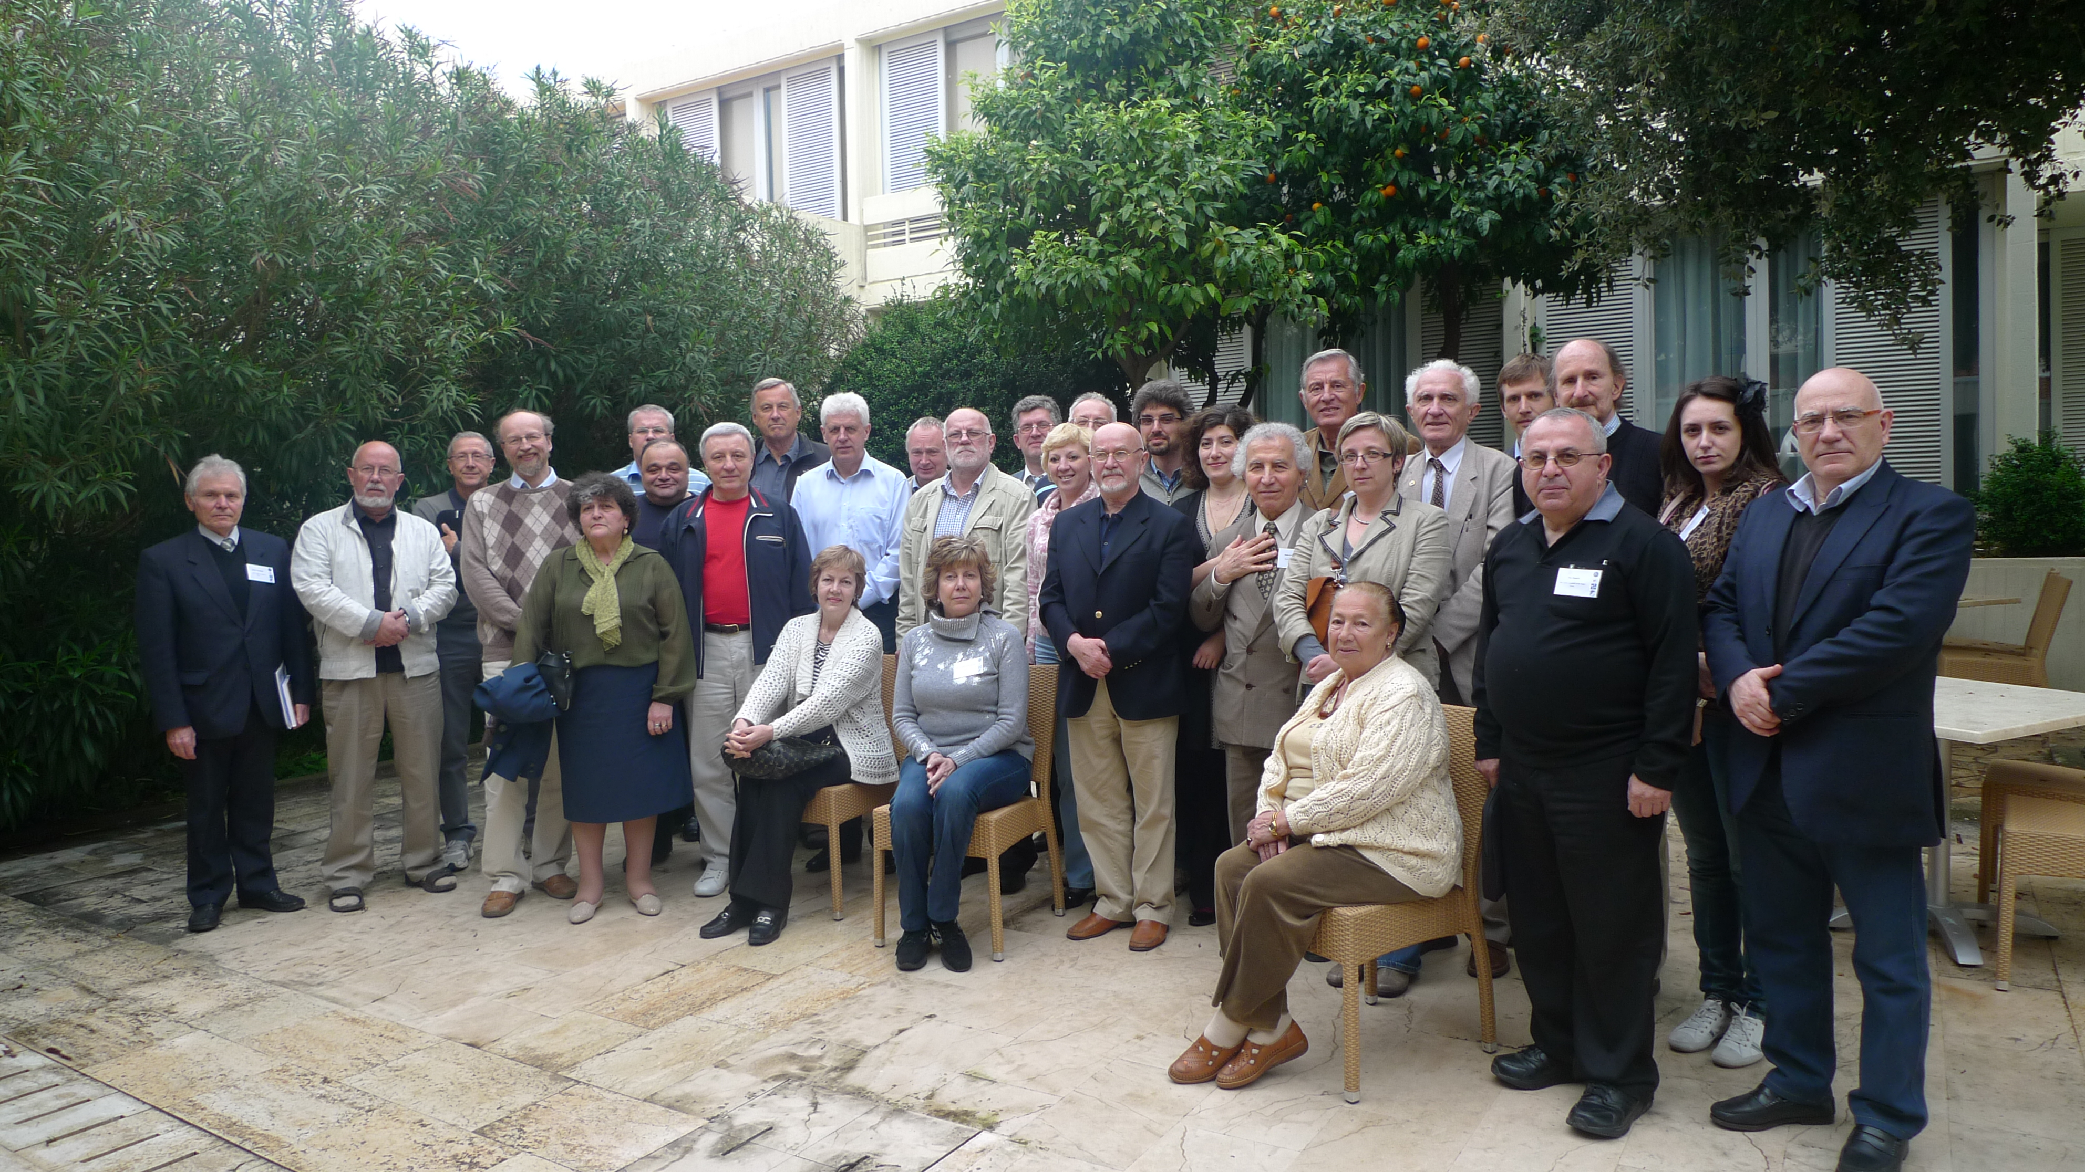

Workshop Attendees, Dubrovnik, 3 May 2011

Some of the workshop conclusions can be summarized as follows:
- Fluctuations of climate correlate with variations of Sun radiation at the scale of hundred years but in the last decades such relationship does not exist.
- The temperature changes given by IPCC are not uniform over the globe. Therefore, true magnitudes of local climate changes require determination of segmented trends on correct scales.
- Urban/megacity effects on climate depend on the scale concerned. Thus, city- and meso-scales are definitely affected by both urban heat island (UHI) and urban emissions, while global-scale climate is affected by urban/megacities emissions, particularly of greenhouse gases and aerosols.
- According to the preliminary calculations by a method developed under the MEGALOPOLIS project and with the contributions of the MEGAPOLI project, the concentration levels of PM10 and NO2 are the most significant for a comprehensive air quality assessment in Moscow. The influence of the Moscow megacity on air quality can be detected as far as 100 km.
- Successful testing of technology for remote sensing monitoring of wildfires, developed under the project MEGAPOLIS, allowed calculating the emission of carbon monoxide from the summer fires of 2010 and evaluating their impact on air quality in Moscow - the largest metropolis in Europe.
- Extreme natural phenomena can drastically deteriorate environmental conditions in urban areas. For example, the effect of the interaction between natural and anthropogenic factors in the atmosphere of the Moscow metropolis during the heat of summer in 2010 led to the fact that on some days the average daily concentrations of gaseous pollutants were higher in 20-30 times than MPC, and single concentration – in 8 times.
- Regional climate change in the Middle East is closely linked to global circulation processes.
- In the absence of gravity waves, the spectral behaviour of winds at mesoscale (spatial scale 1 - 500 km, temporal scale 10 min – 24 h) is similar to one described in literature, and, the Taylor hypothesis is valid. However, well organized gravity waves modify above conclusions.
- Life-times and spatial scales of the semi-organized structures (i.e. cloud streets and cloud cells) are much larger than the turbulent scales.
- The direction of the geostrophic wind is an important control parameter for the Ekman Boundary Layer (EBL). Thus, it must be introduced to the EBL parameterization as a new control parameter.
- Mass concentrations of particulate matter with aerodynamic diameter up to 1 µm (PM1) increase with an increase of relative humidity.
- Po Valley pollutants emissions impact the regional air quality at distances up to at least 500 km. Areas affected by these emissions are larger during the winter, while the mass of pollutants injected in the free troposphere is larger during the summer.

Workshop participants also highlighted the importance of educational and specifically inter-disciplinary educational programs, such as programs on physical and chemical weather, climate change adaptation etc. Finally, they raised some scientific questions, which need further investigations, such as:
- How large is the current impact of megacities on regional and global climate?
- How will the growth of megacities affect future climate at global and regional scales?

The participants stressed that MEGAPOLIS – MEGAPOLI partner projects results show the efficient cooperation of EU and Russian Federation in national environmental monitoring systems, and, the need to integrate the international practice in formation of similar projects.

